HTTP API Method Throttling

1. Open an HTTP API like Query Google
2. Connect to the lambda function that queries google by using the following URL

<https://g2cjb0ygaf.execute-api.us-west-2.amazonaws.com/Google>

1. Now click the HTTP API and on the left hand side click “Throttling”
2. We can see the account throttling setting that is 10000 rate limit and 5000 Burst limit.
3. We can see that there is no setting under the default route throttling for this API
4. Under “Default Route Throttling” click edit
5. Place “Burst limit:1” and “Rate limit:1” and save
6. Start clicking f5 to refresh quickly and we will notice receiving an error stating “Message: Too many requests”
7. Right click on the page a click “Inspect”.
8. Move to the Network tab and click on the error icon on the top right to see the error response of 429

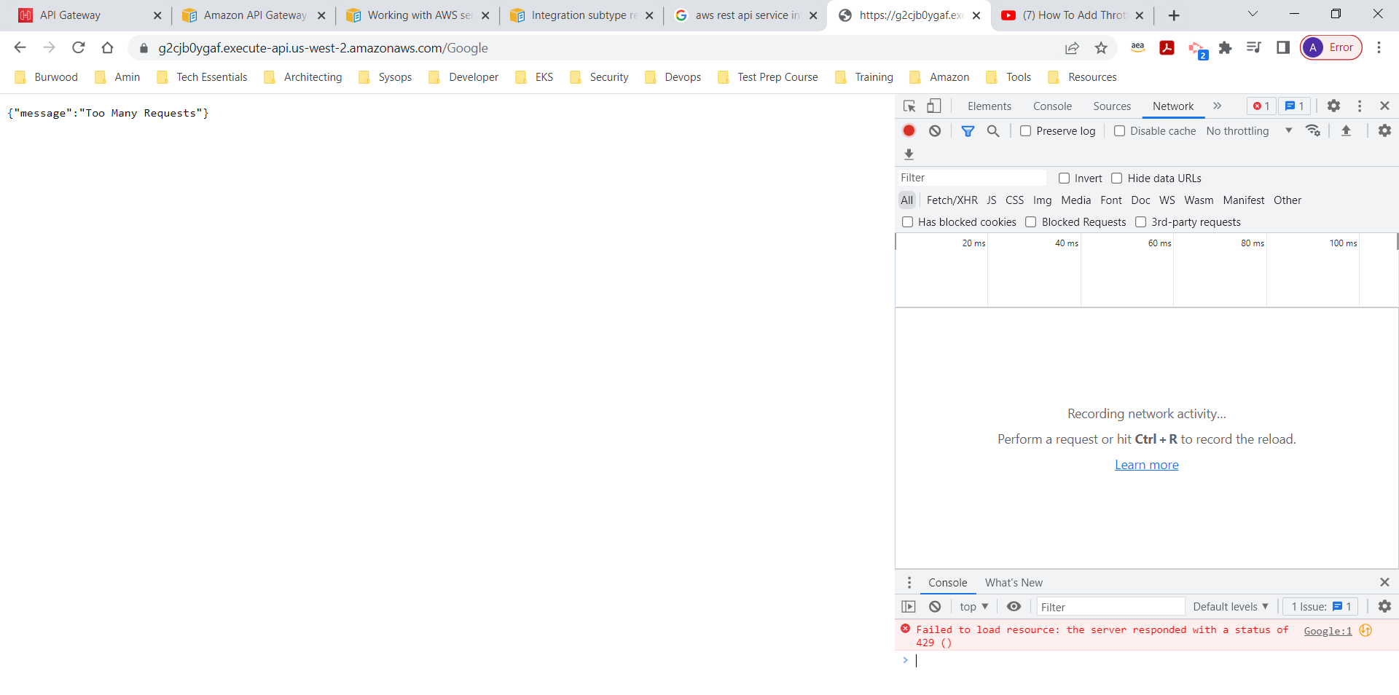

1. If a route has custom throttling settings we can apply it at the “Route settings on Stage” box. This section does not have a setting through the dashboard and we can use a cli command to configure this setting.

aws apigatewayv2 update-stage –api-id <Place API Id here> --stage-name <place stage name here> --route-settings ‘{“GET /<route name>”: {“ThrottlingBurstLimit”:100 “ThrottlingRateLimit”:”2000”}}’